

**Grow Green**

## MINI-PROJECT REPORT

***by***

# Meet Vachhani (IU1941050079)

# Saad Kadri (IU2041051092)

# Pratham Shah (IU2041051095)

## Department of Computer Engineering

Indus Institute of Technology and Engineering

## Ahmedabad

## July-December & 2022

**BONAFIDE CERTIFICATE**

This is to certify that this project report entitled **“Grow Green”** submitted to **Department of** **Computer Engineering, IITE, Ahmedabad**, is a bonafide record of work done by “**Meet Vachhani, Saad Kadri, Pratham Shah”** under my supervision from **“04-07-22”** to **“21-10-22”**

**Mr. Abhishek N Vaghela  
Assistant Professor,**

Place

Date

**ACKNOWLEDGEMENT**

The final outcome of this report took a lot of help and dedication from our colleagues. We would like to sincerely thank them for their effort. We would also like to extend our graduation toward to our mentor who have helped us throughout this report and through the junction. We are incredibility thankful for our college and the computer department for providing us with all the helpful material. We enjoy and learnt a lot by creating this report and hope that the same will be left from the reader.

# Meet Vachhani (IU1941050079)

# Saad Kadri (IU2041051092)

# Pratham Shah (IU2041051095)

**5.1 Design Layout**

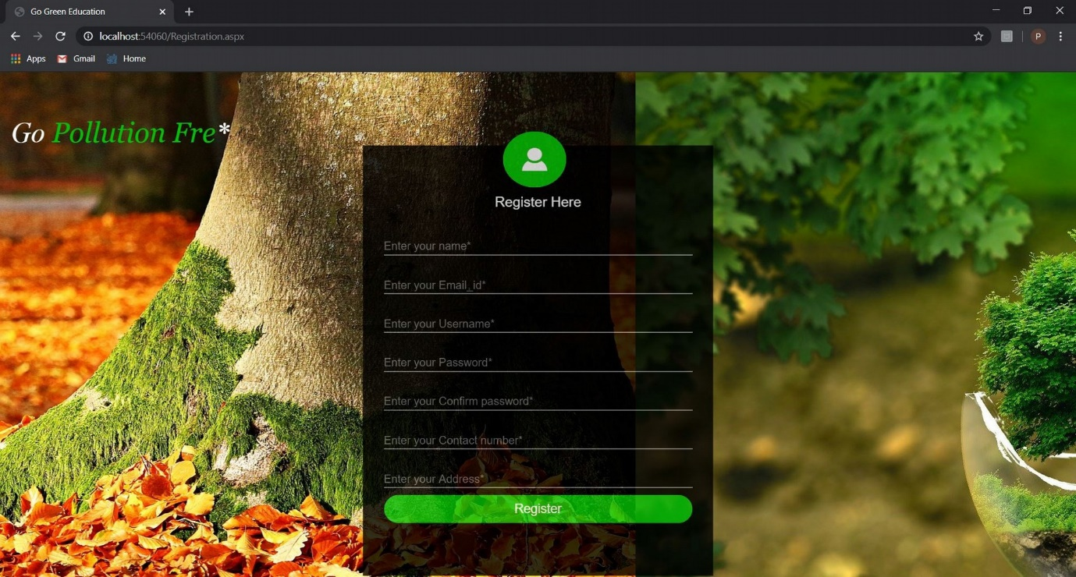

**[Figure: Registration Page]**

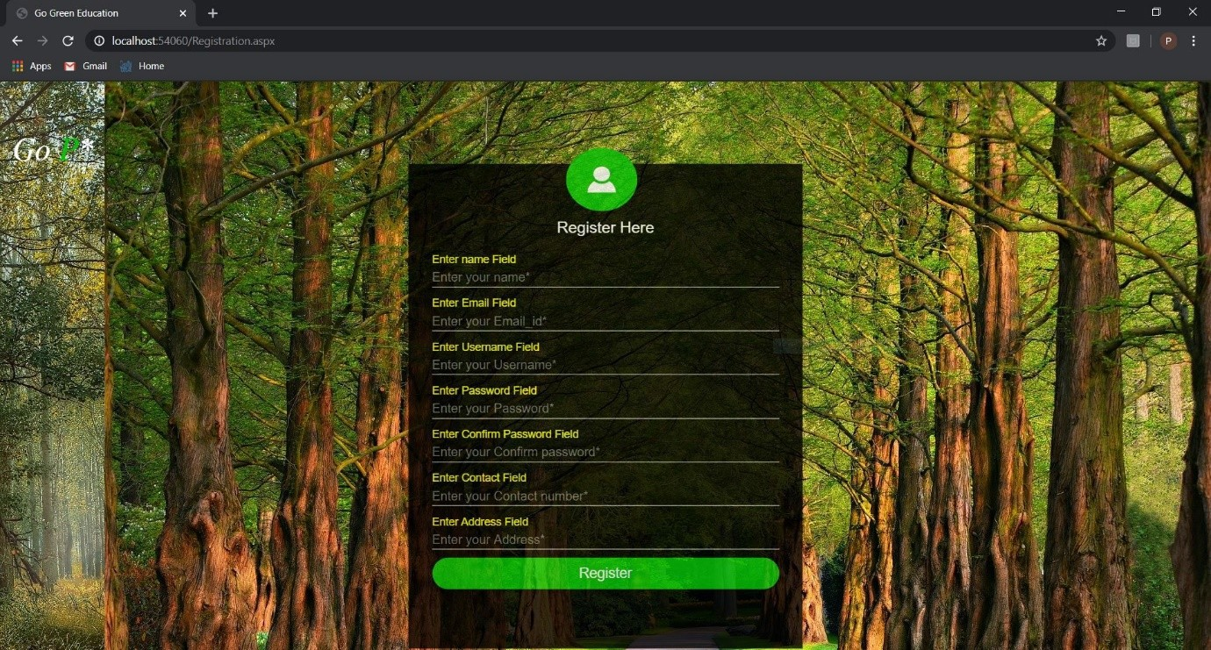

**[Figure: Registration Form Validation]**

25

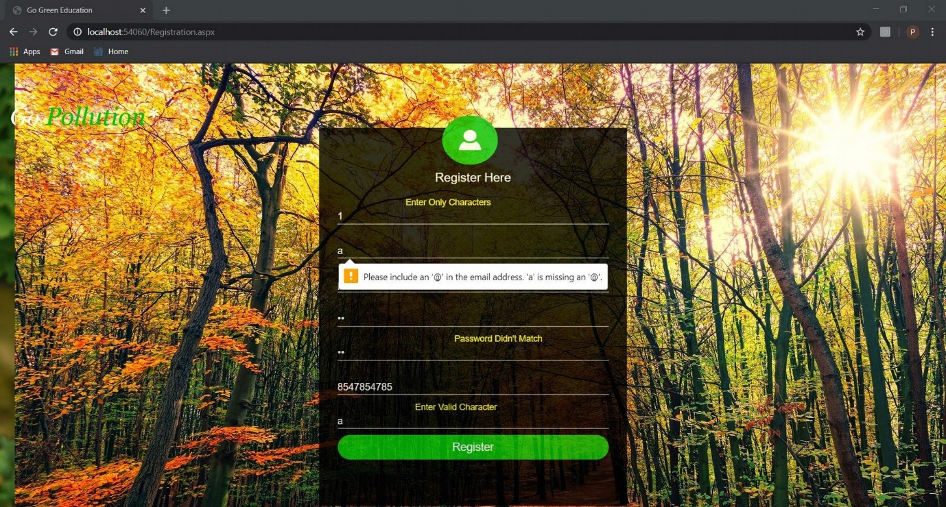

**[Figure: Validation In Registration Form]**

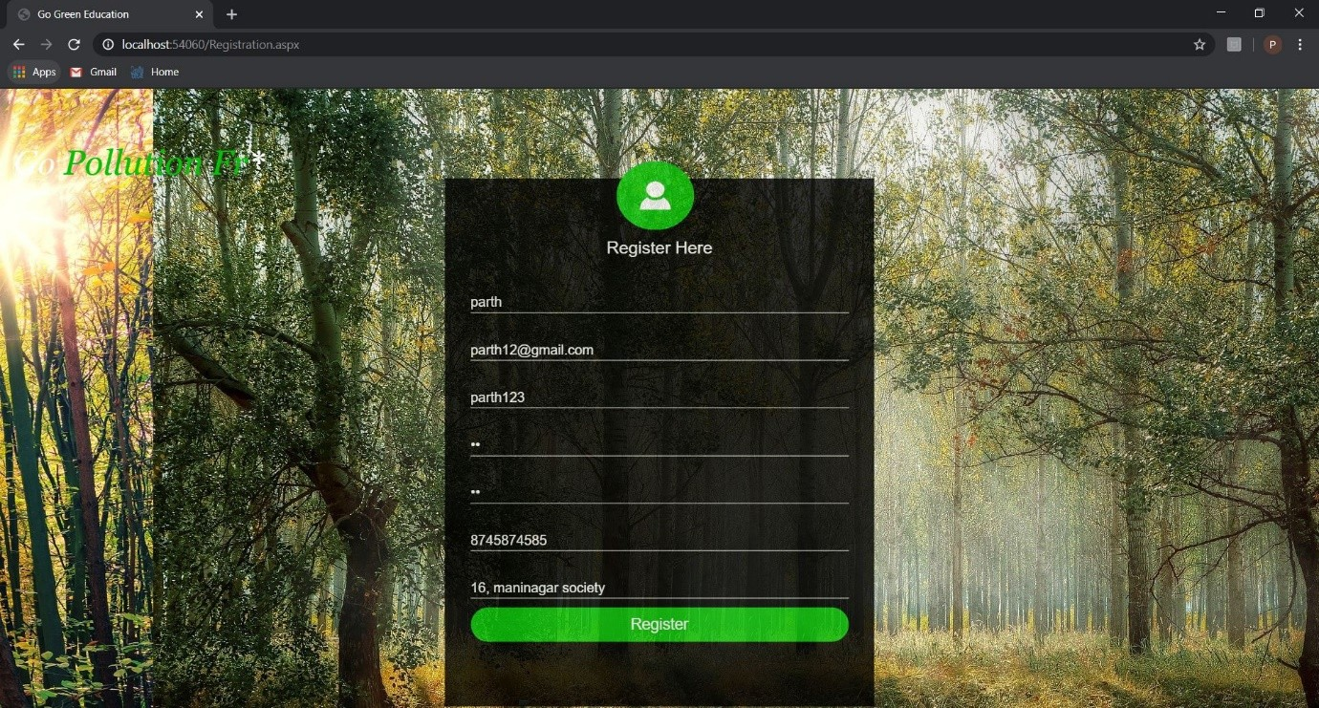

**[ Figure: Valid Registration & Redirect Login Page ]**

26

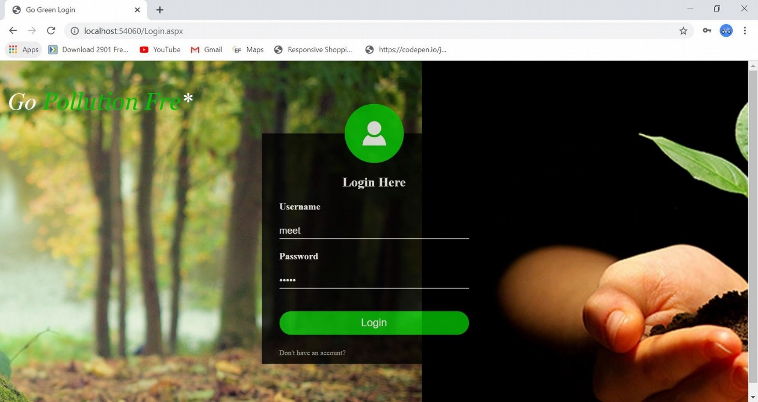

**[Figure: After Registration]**

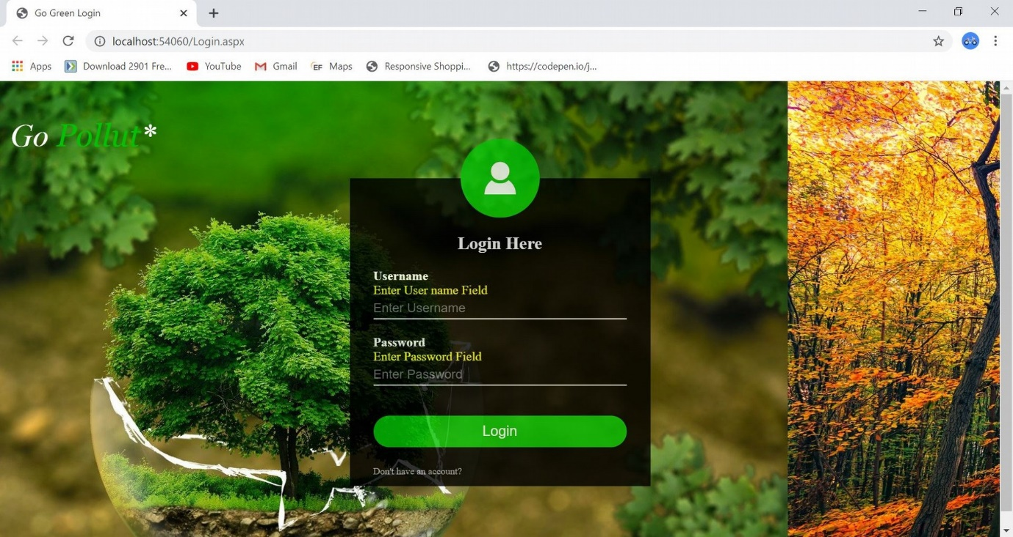

**[Figure: Validation In Login Form]**

27

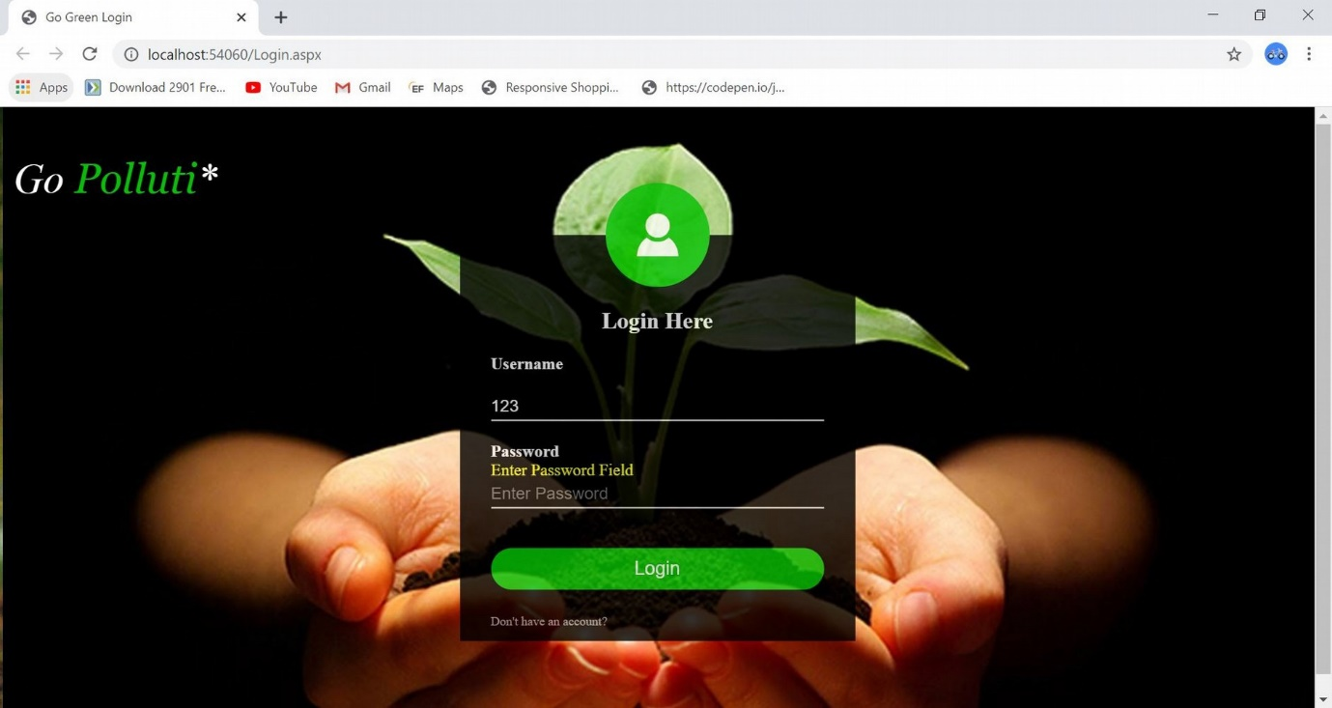

**[Figure: Password Validation]**

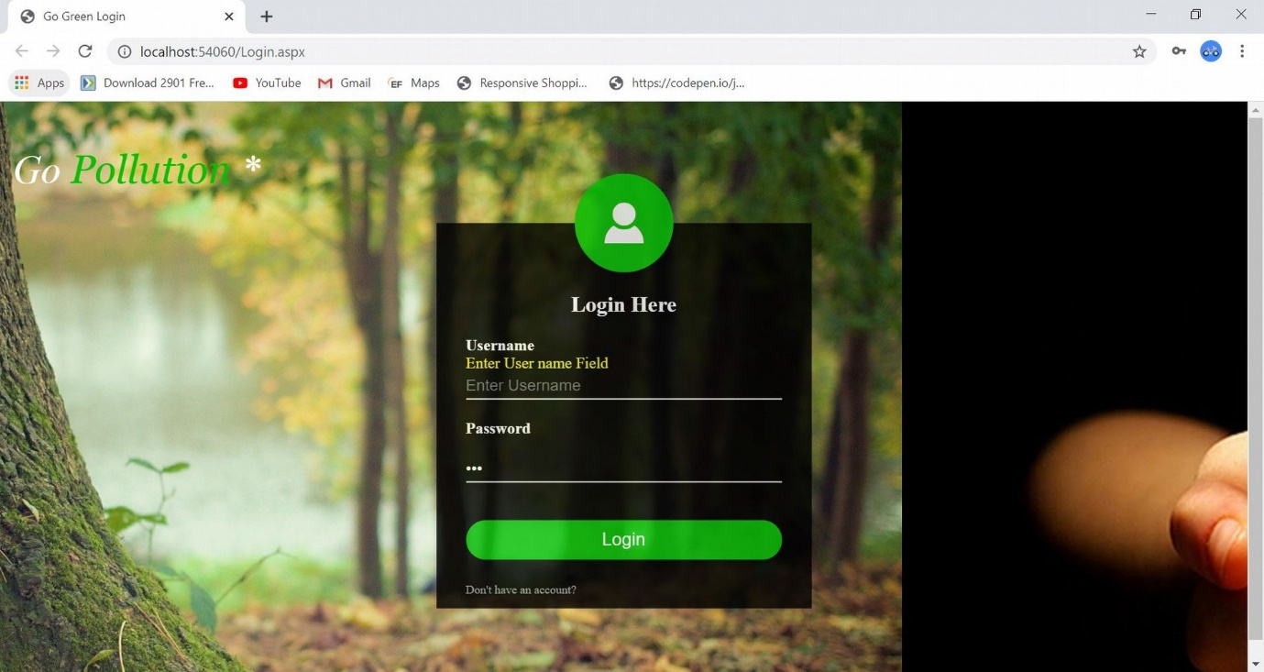

**[Figure: Username Validation]**

28

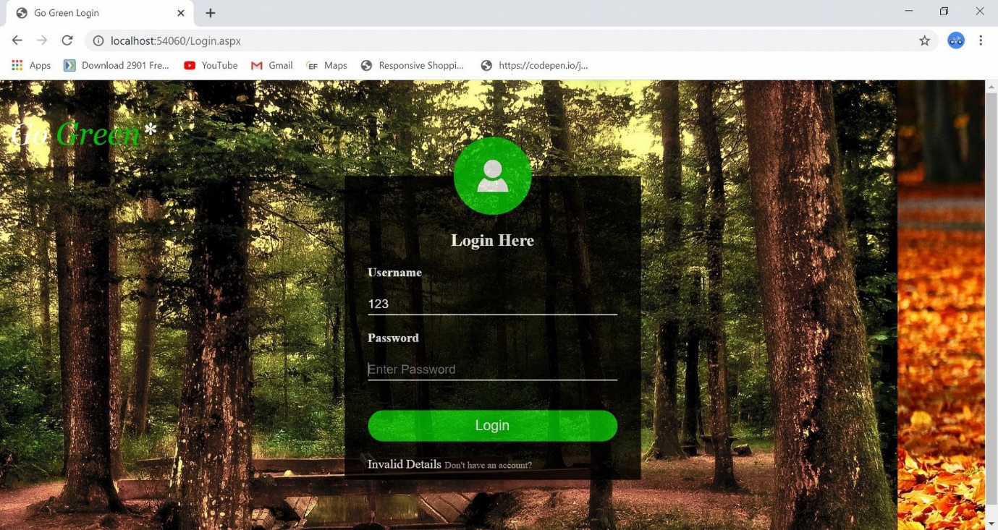

**[Figure: Login Form]**



**[Figure: Valid Login]**

29

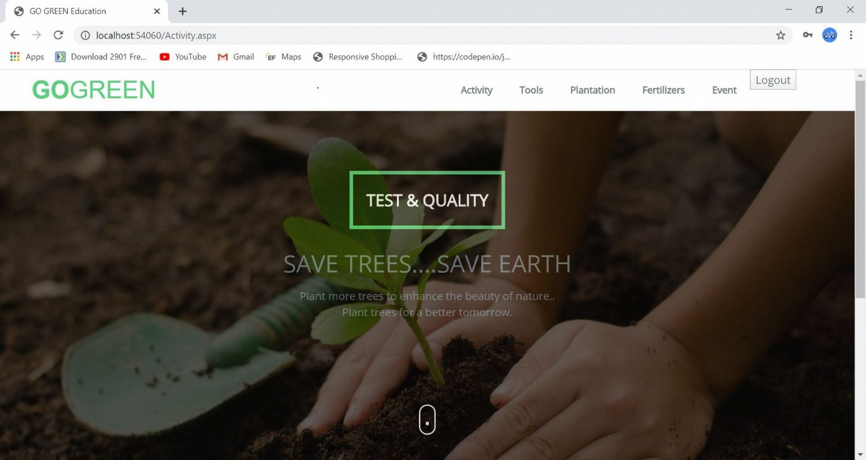

**[Figure: After Successful Login Activity Page]**

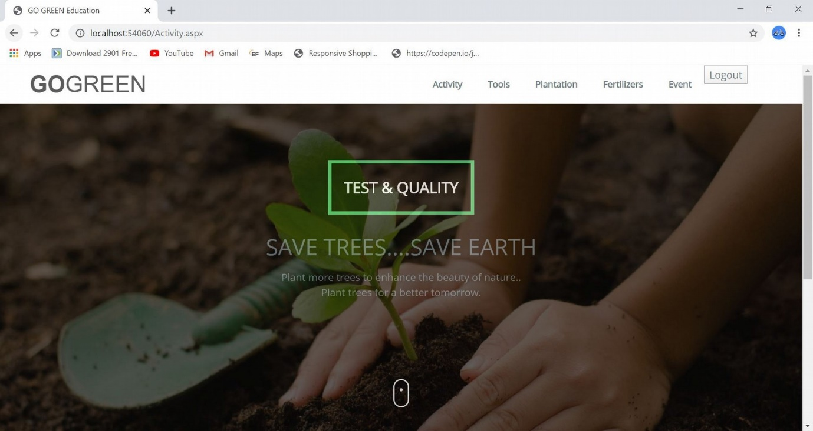

**[Figure: Activity Page]**

30

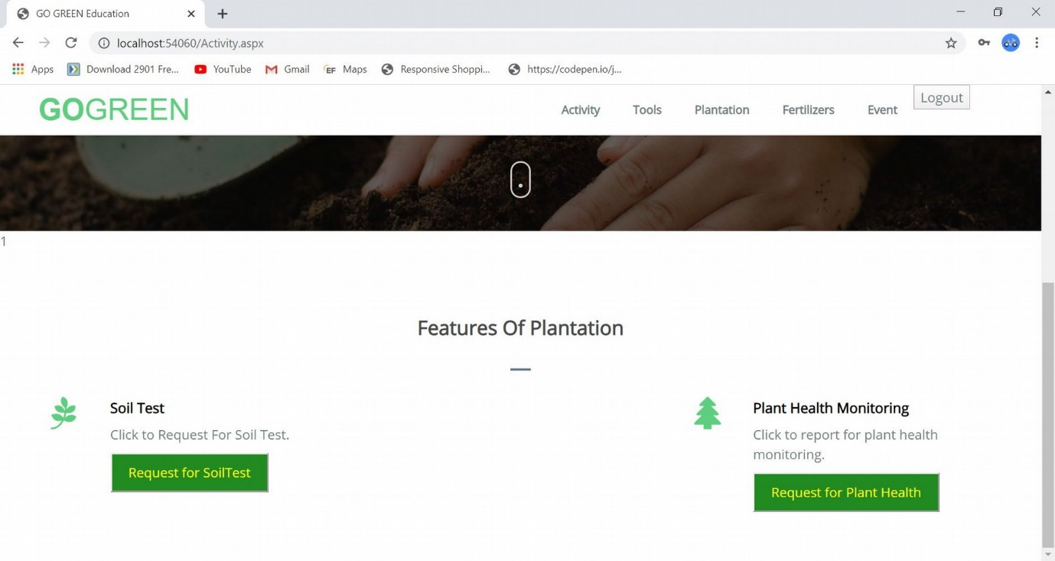

**[Figure: Activity Page Scroll Down]**

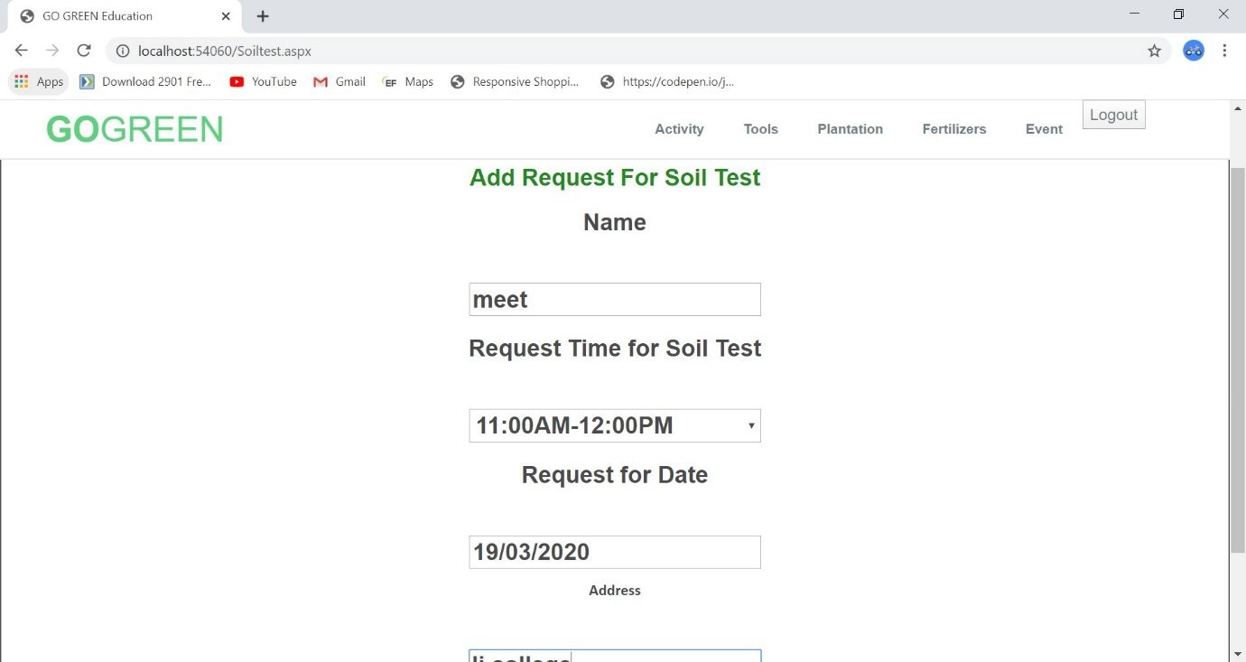

**[Figure: Soil Test Form]**

31

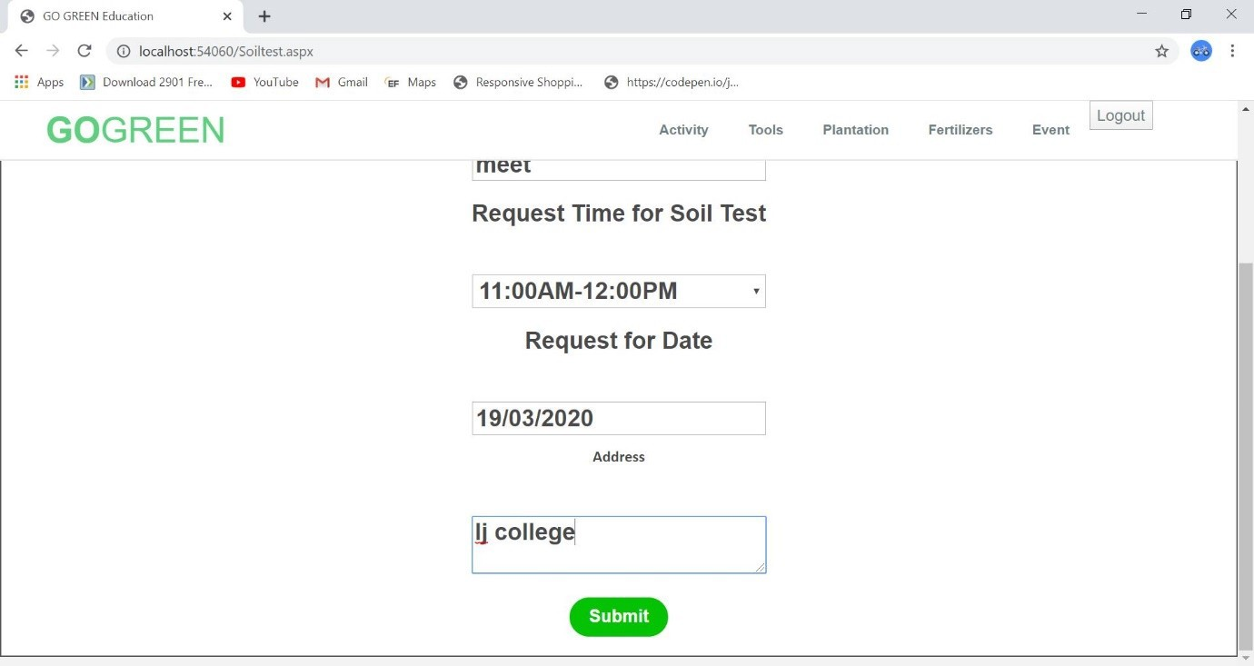

**[Figure: Soil Test Form Submit Scroll]**



**[Figure: After Soil Test Form Submit Activity Page Redirect]**

32

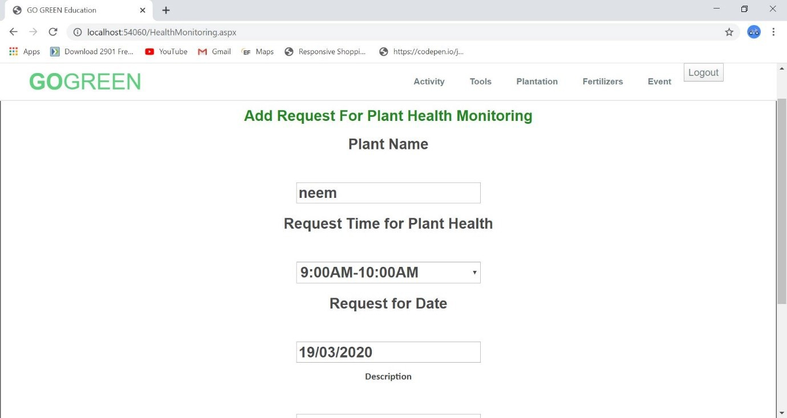

**[Figure: Plant Health Monitoring Form]**

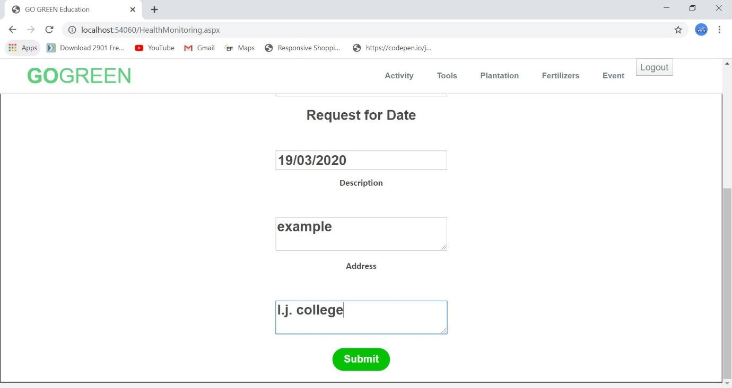

**[Figure: Plant Health Monitoring Form Submit]**

33



**[Figure: After Submit Plant Health Monitoring Form]**

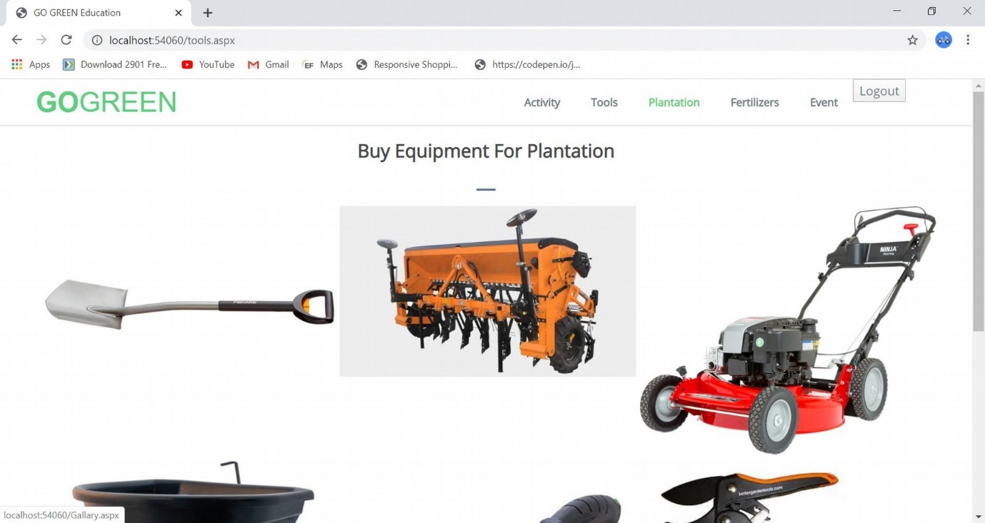

**[Figure: Page For Buying Tools/Equipment]**

34

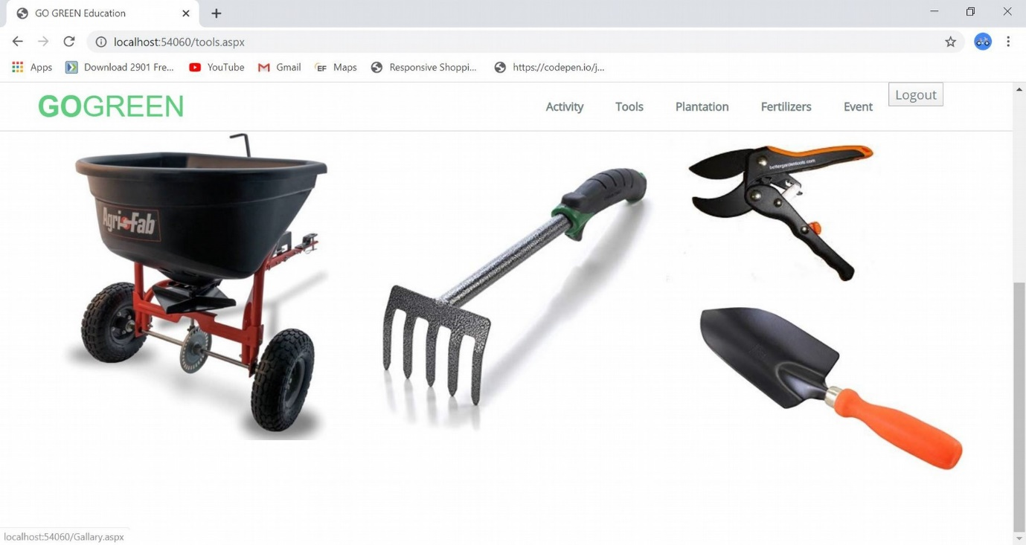

**[Figure: Tools Page Scroll Down]**

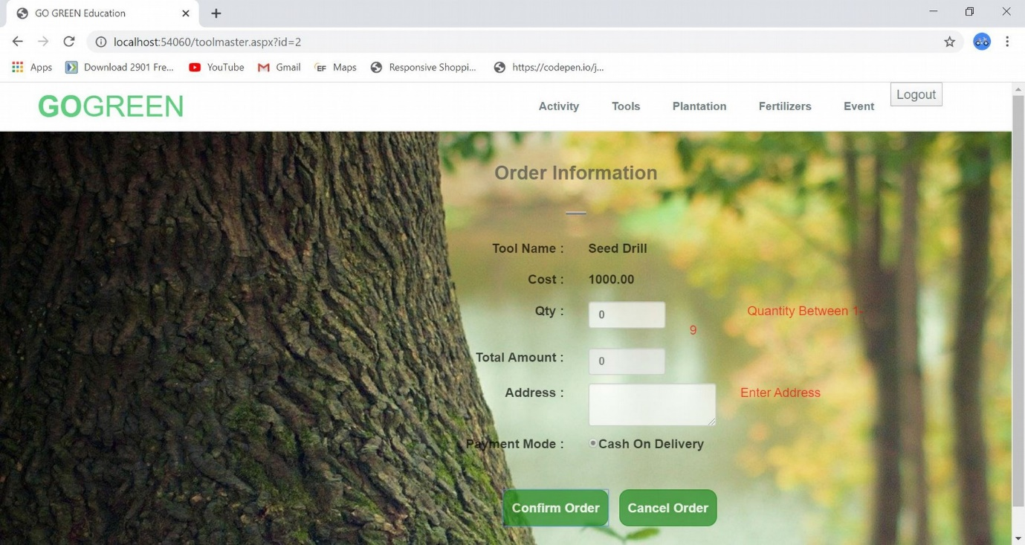

**[Figure: Tools Page Validation]**

35

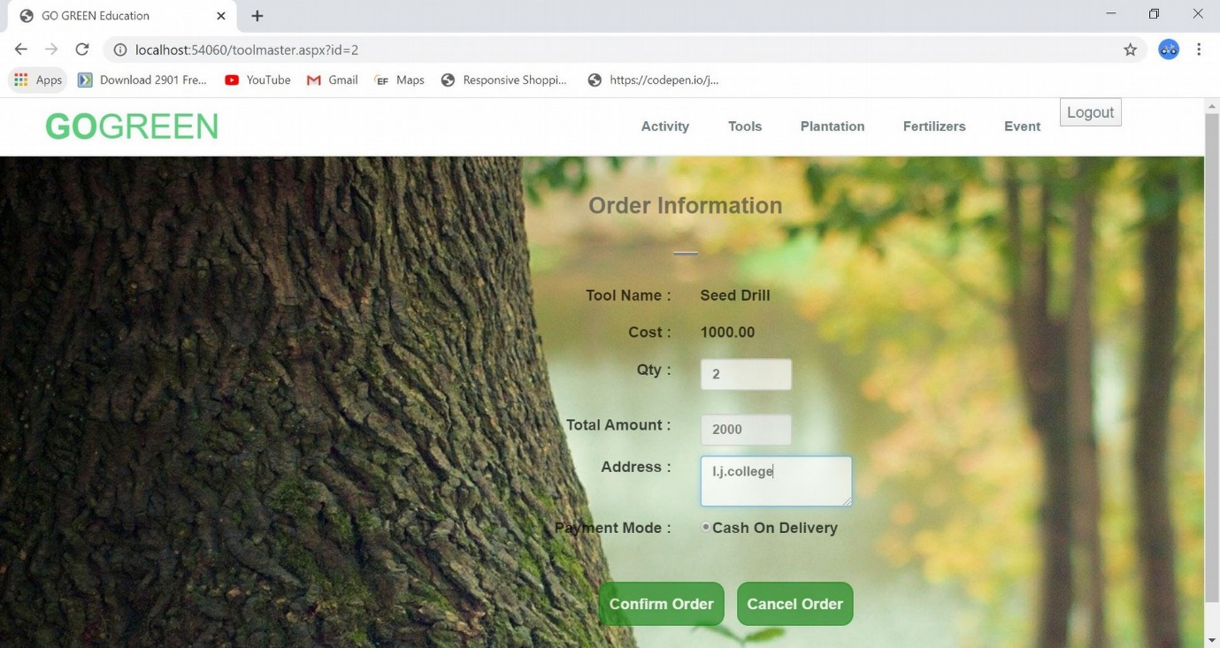

**[Figure: Valid Details For Buy Tools]**

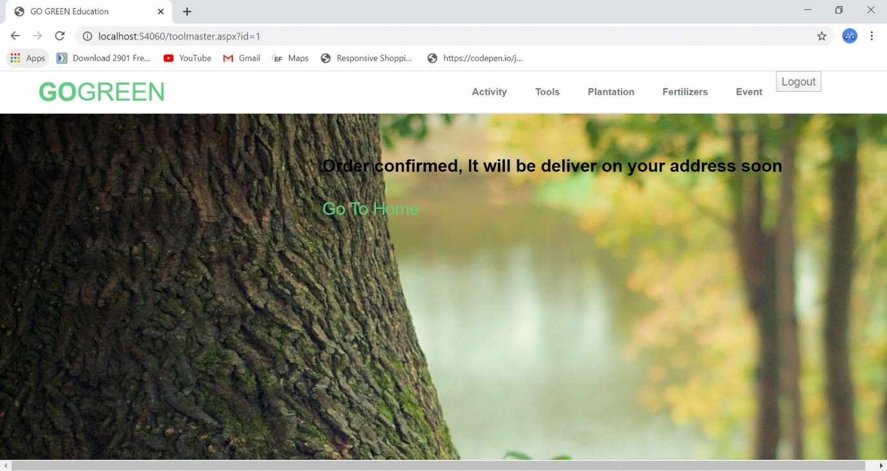

**[Figure: Order Confirm For Tools]**

36

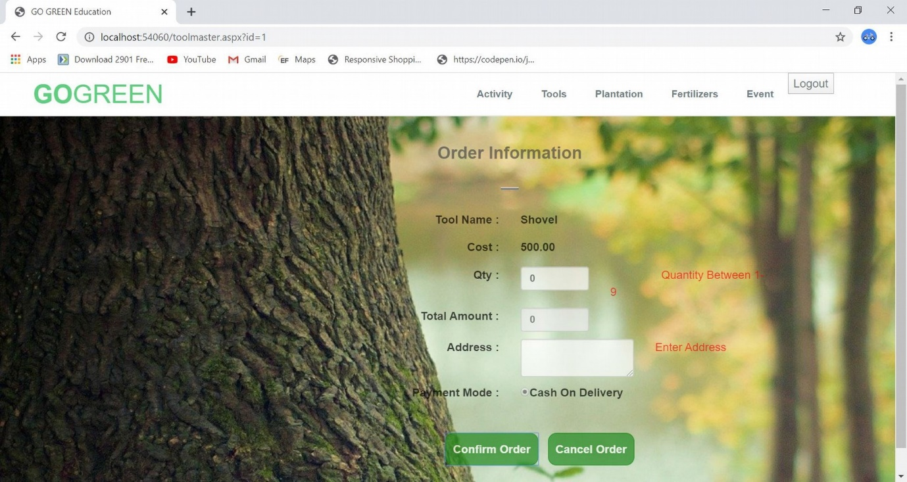

**[Figure: Validation For Tools Example-2]**

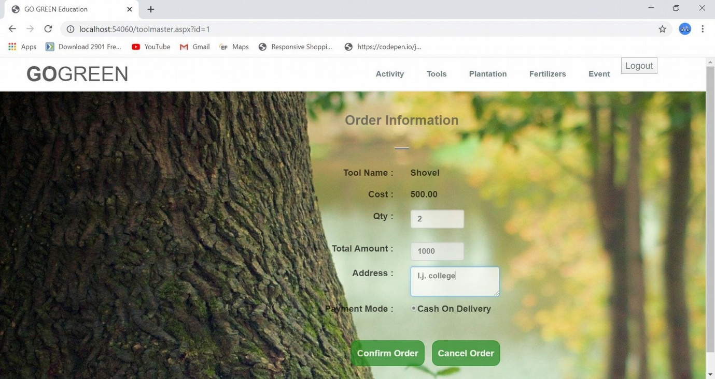

**[Figure: Valid Details For Buy Tools Example-2]**

37



**[Figure: Order Confirm For Tools Example-2]**

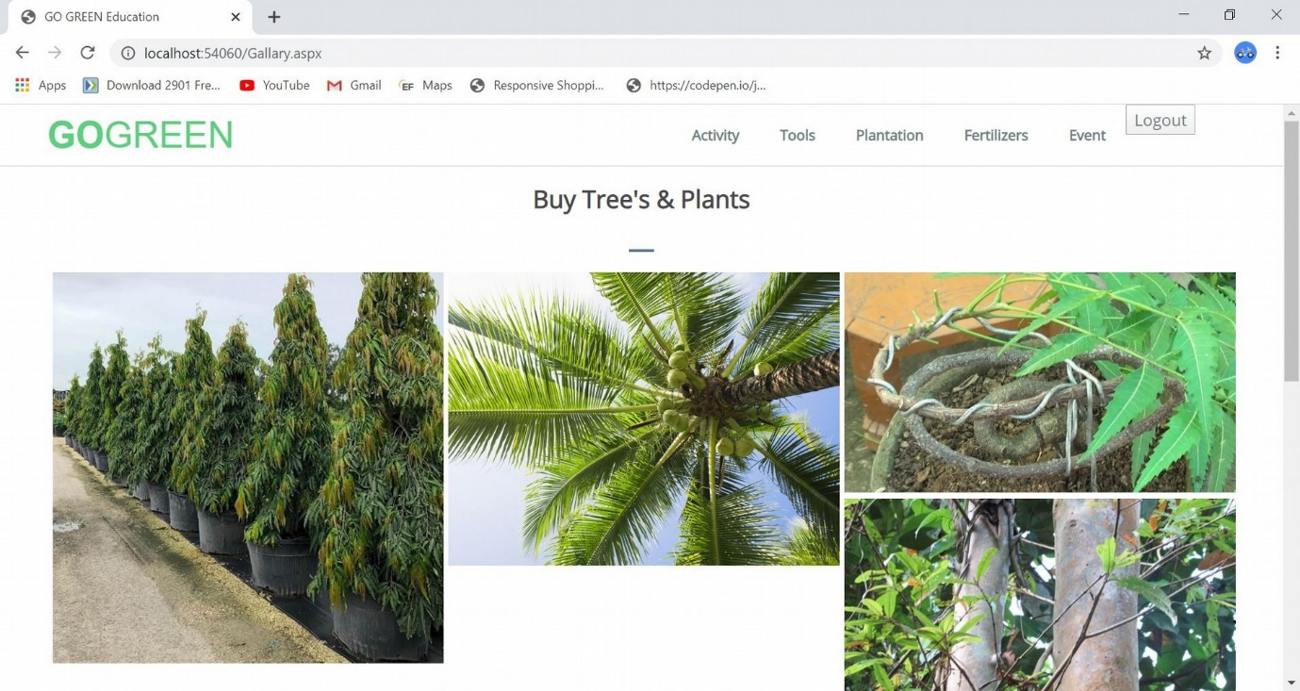

**[Figure: Plantation Page]**

38

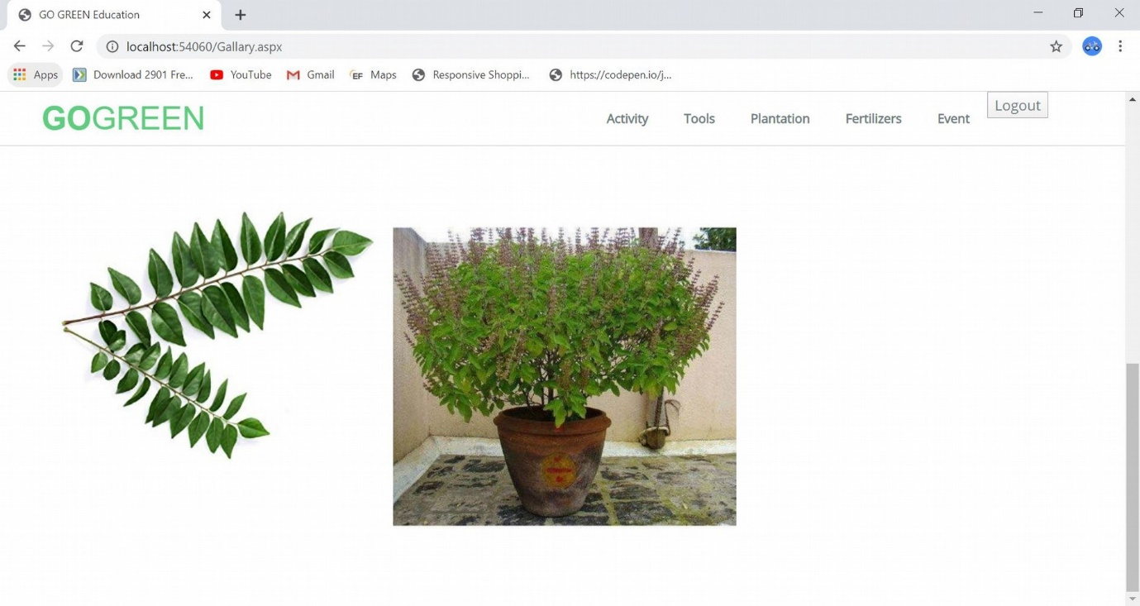

**[Figure: Plantation Page Scroll Down]**

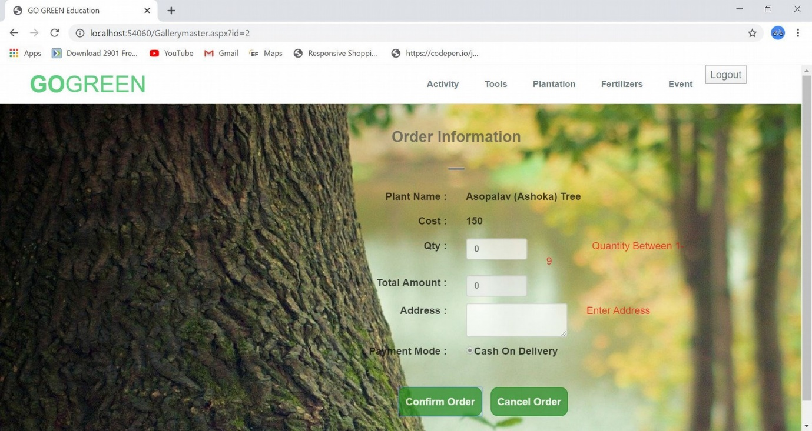

**[Figure: Plantation Page Validation]**

39

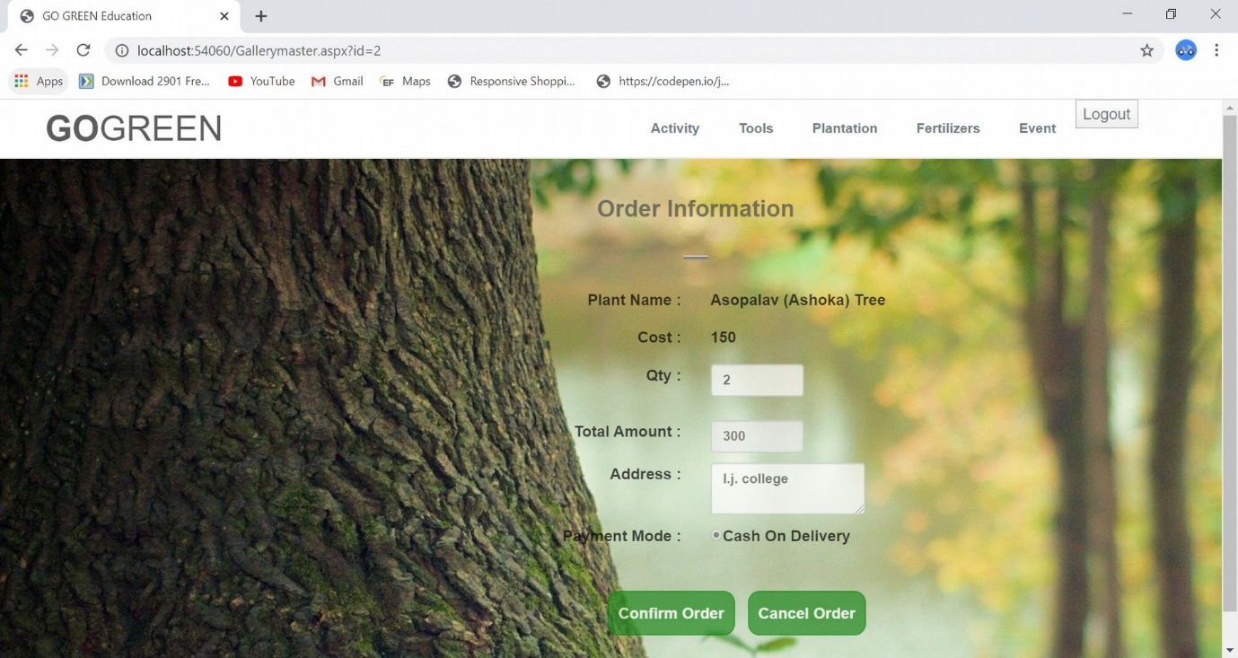

**[Figure: Valid Details For Buy Plantation]**

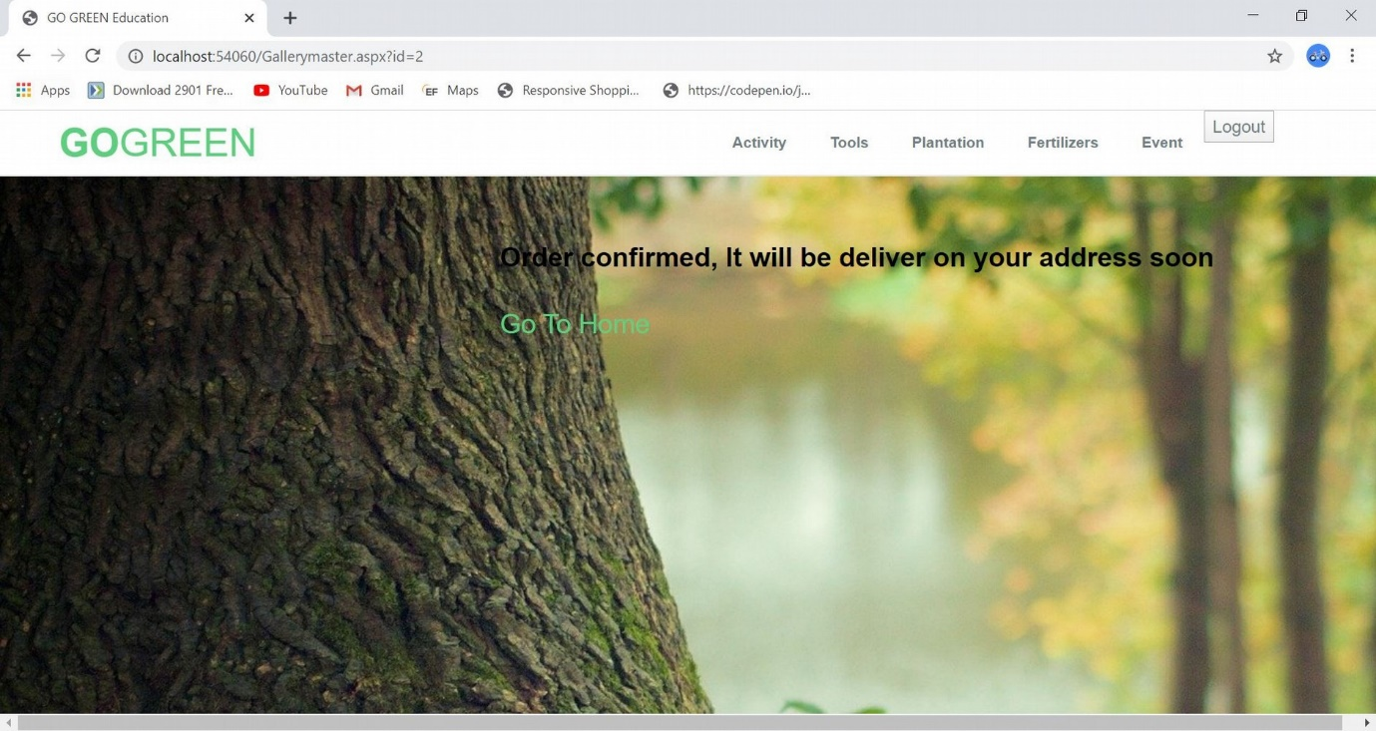

**[Figure: Order Confirm For Plantation]**

40

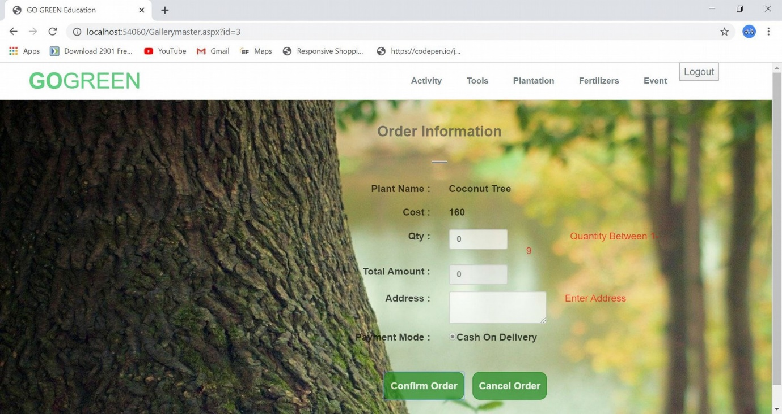

**[Figure: Validation For Plantation Example-2]**

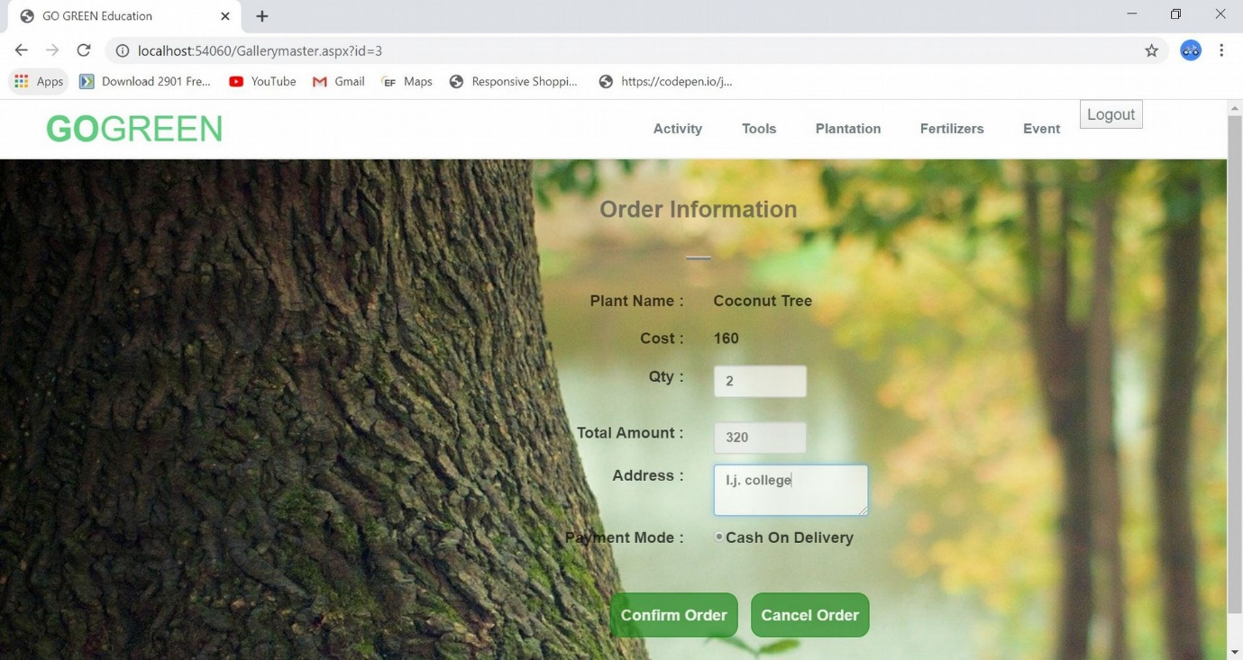

**[Figure: Valid Details For Buy Plantation Example-2]**

41



**[Figure: Order Confirm For Plantation Example-2]**

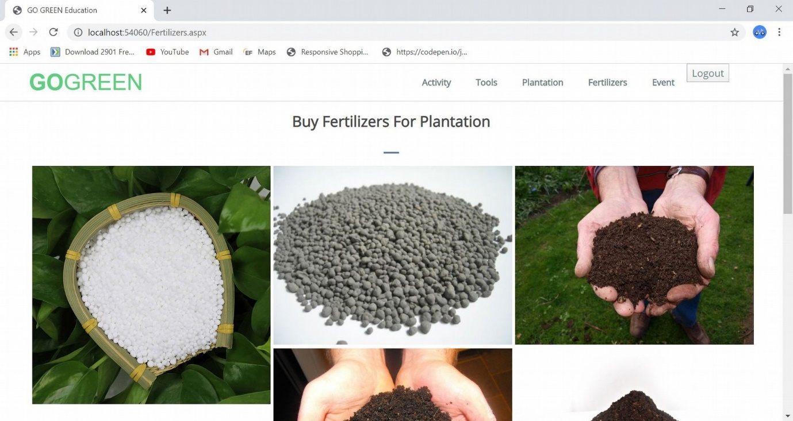

**[Figure: Fertilizer Page]**

42

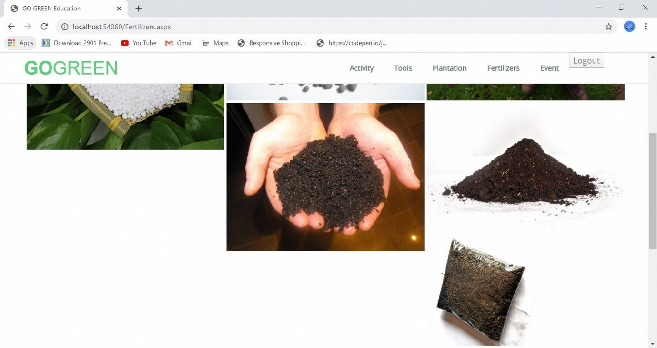

**[Figure: Fertilizer Page Scroll Down 2]**

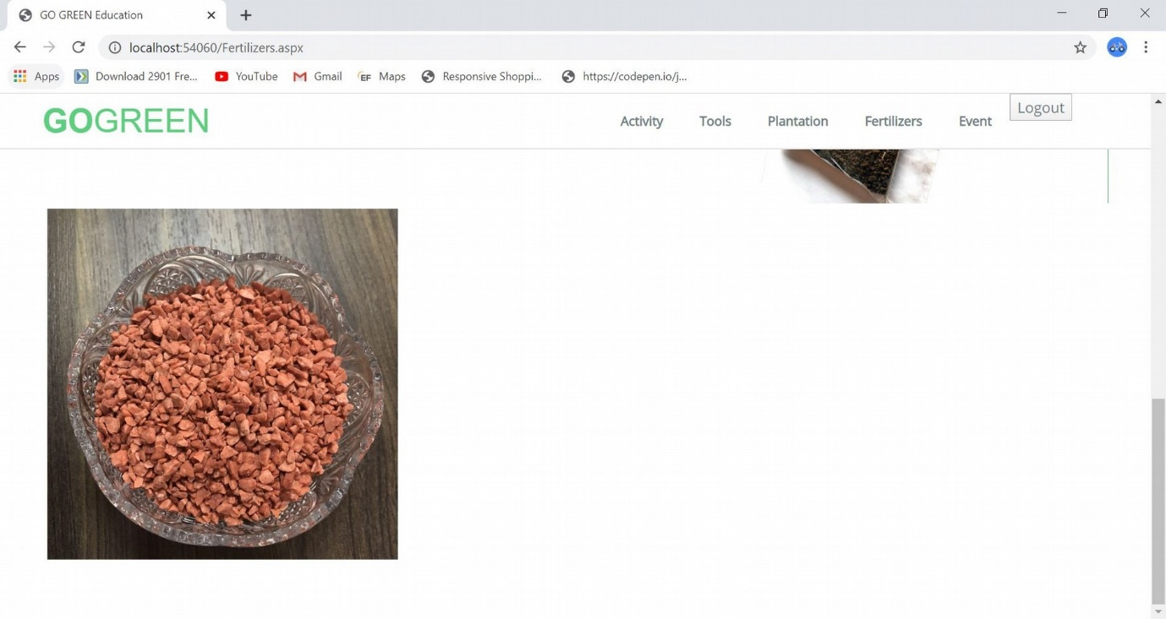

**[Figure: Fertilizer Page Scroll Down 3]**

43

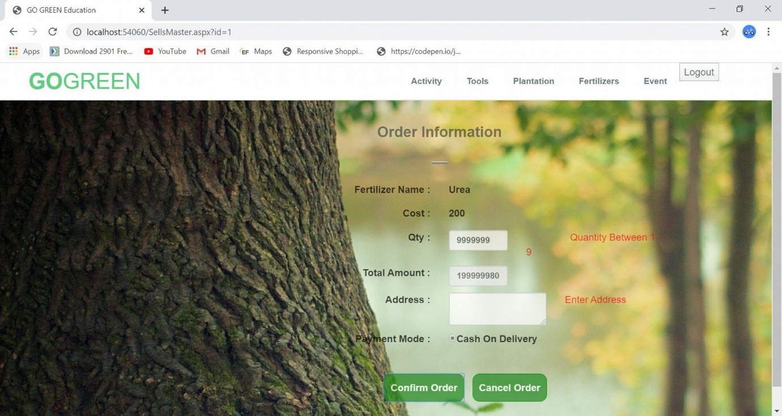

**[Figure: Validation For Buy Fertilizer]**

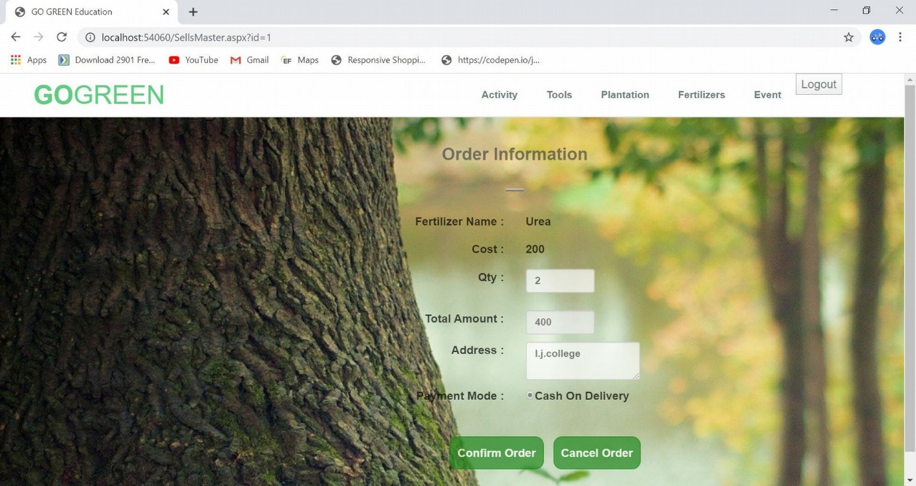

**[Figure: Valid Details For Buy Fertilizer]**

44

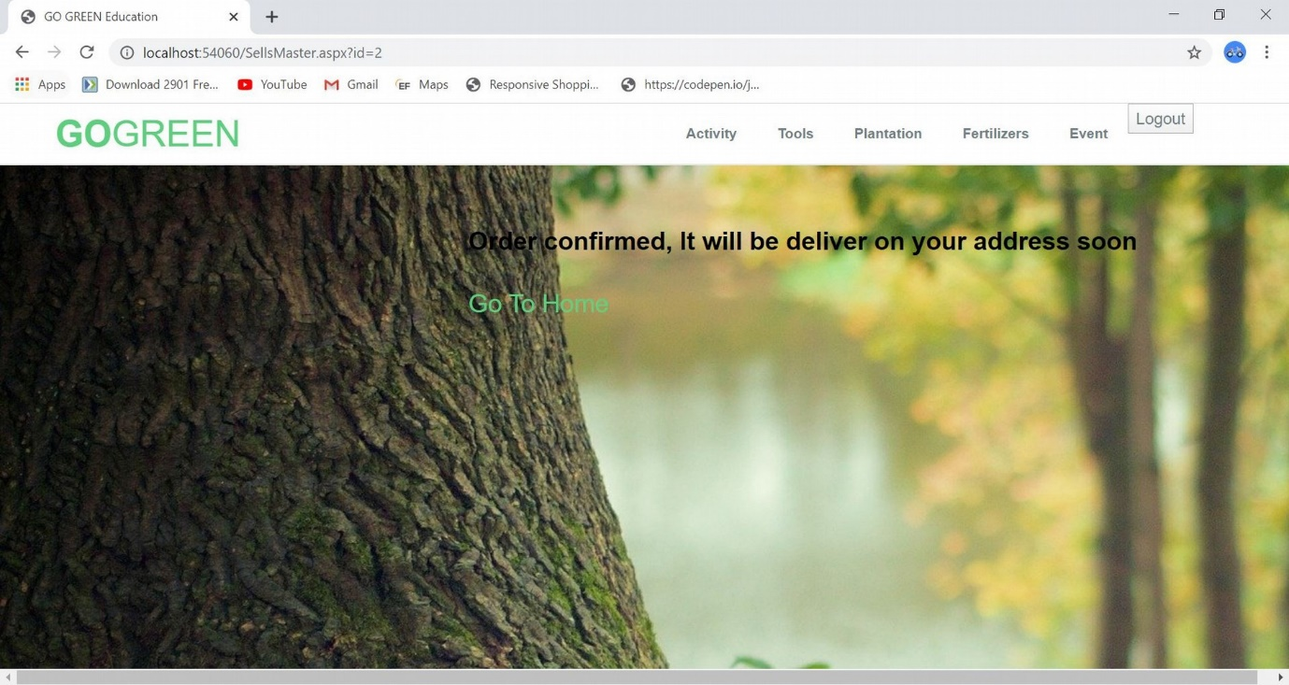

**[Figure: Order Confirm For Fertilizer]**

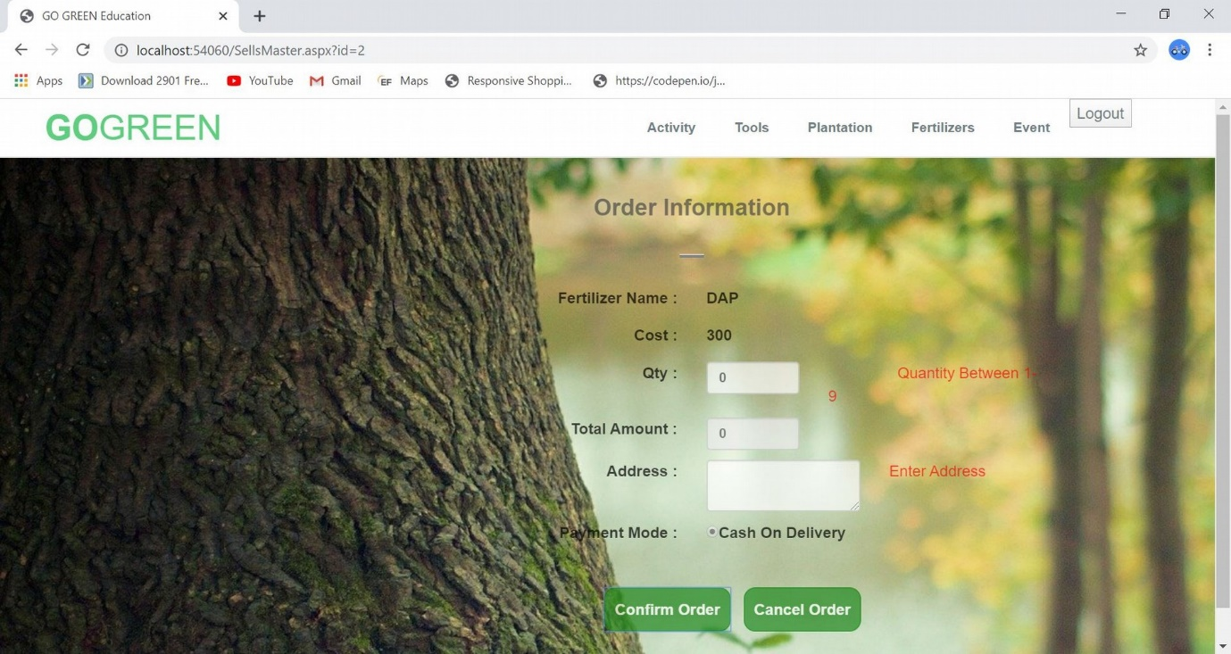

**[Figure: Validation For Fertilizer Example-2]**

45

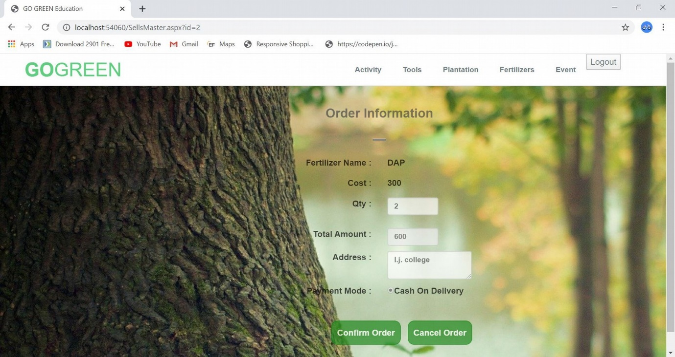

**[Figure: Valid Details For Buy Fertilizer Example-2]**

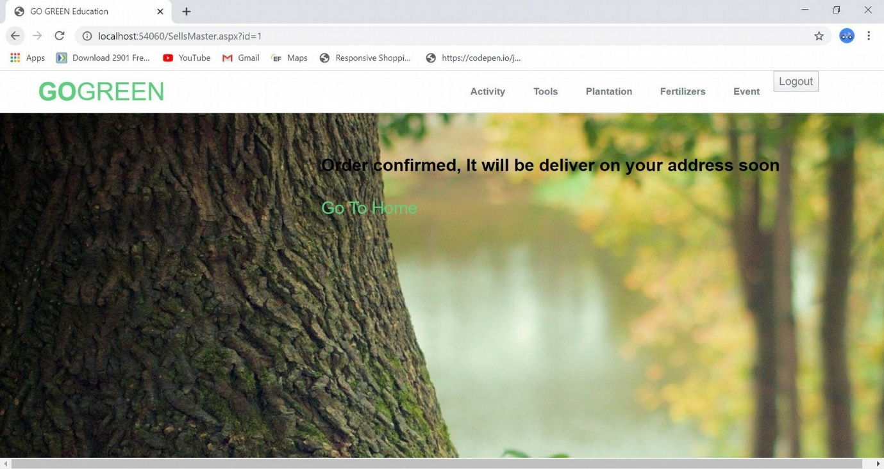

**[Figure: Order Confirm For Fertilizer Example-2]**

46

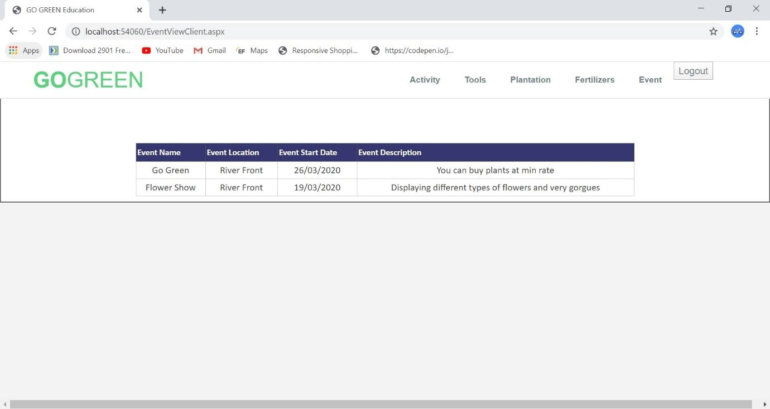

**[Figure: Event display page]**

**[ADMIN PANEL VIEW]**

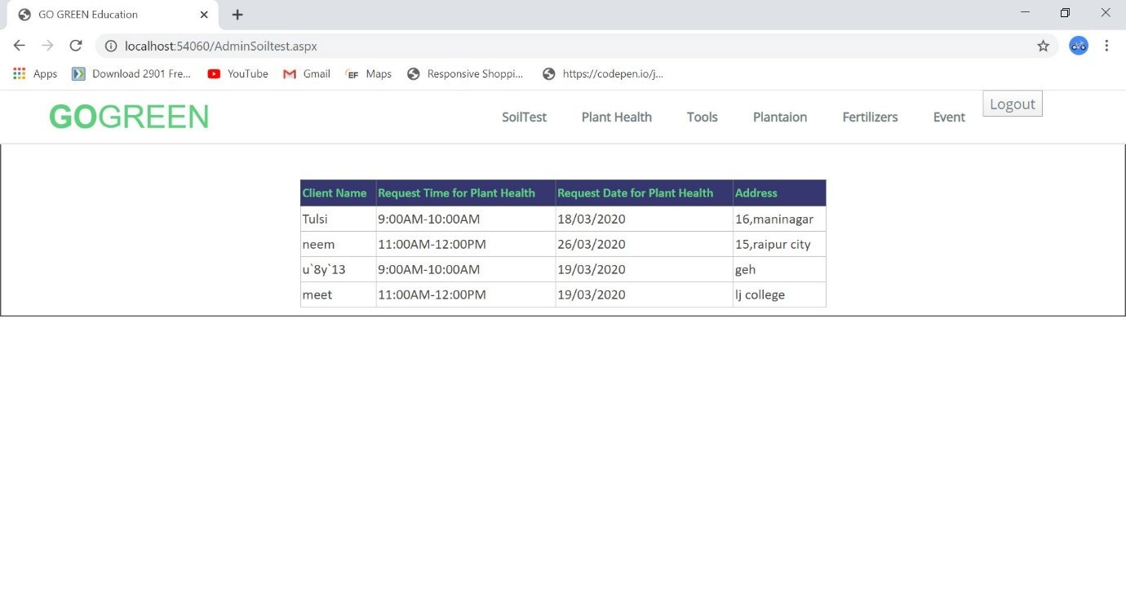

**[Figure: Soil Test]**

47

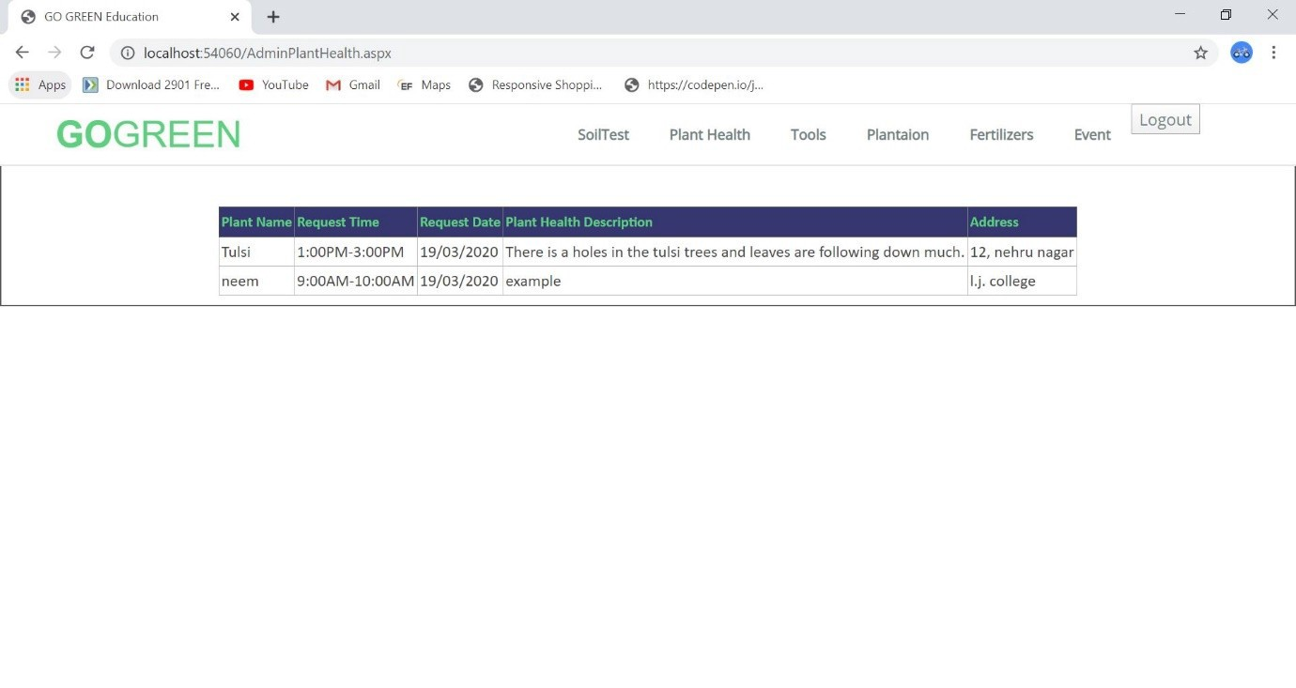

**[Figure: Plant Health]**

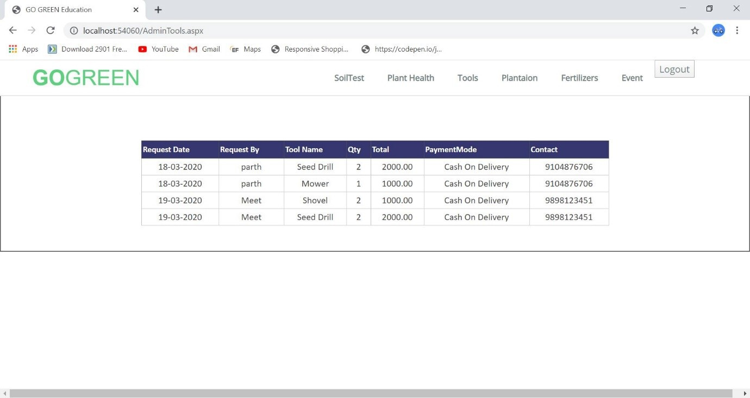

**[Figure:Tools]**

48

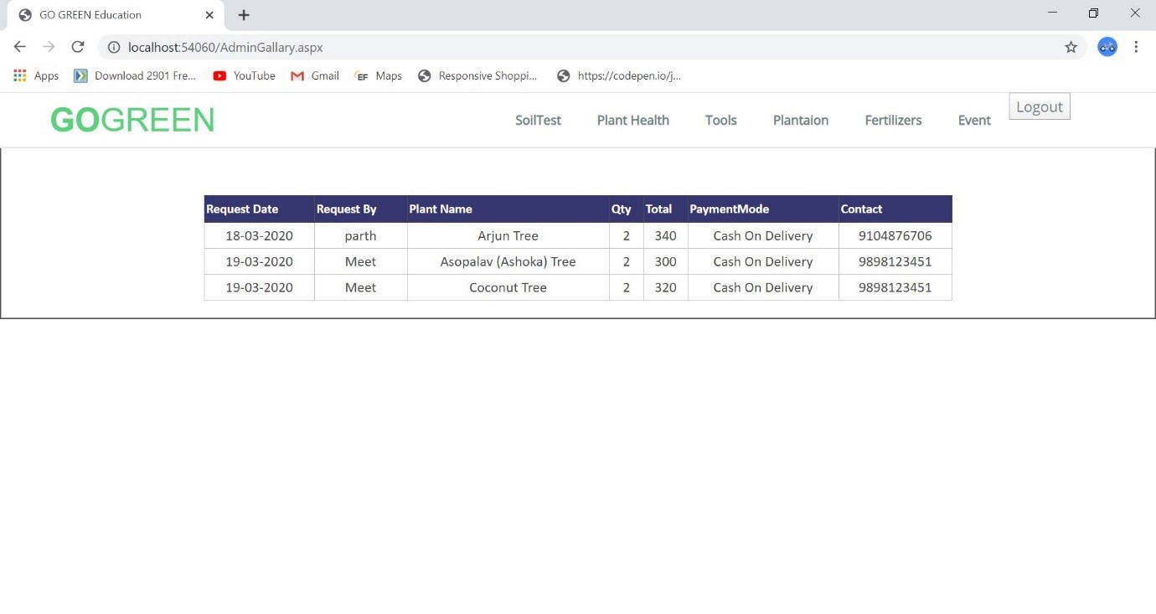

**[Figure:Plantation]**

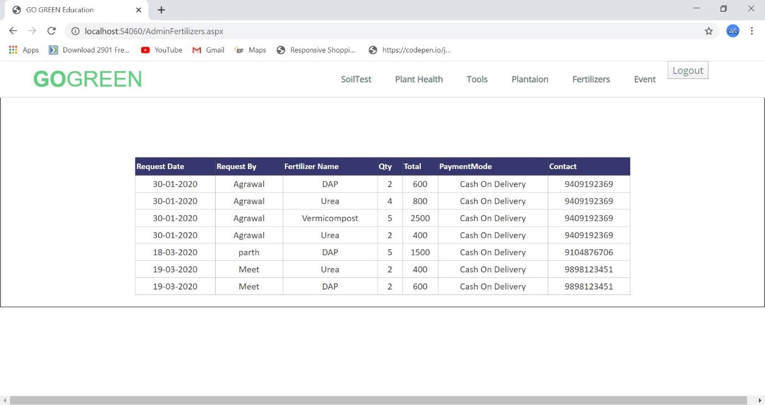

**[Figure:Fertilizer]**

49

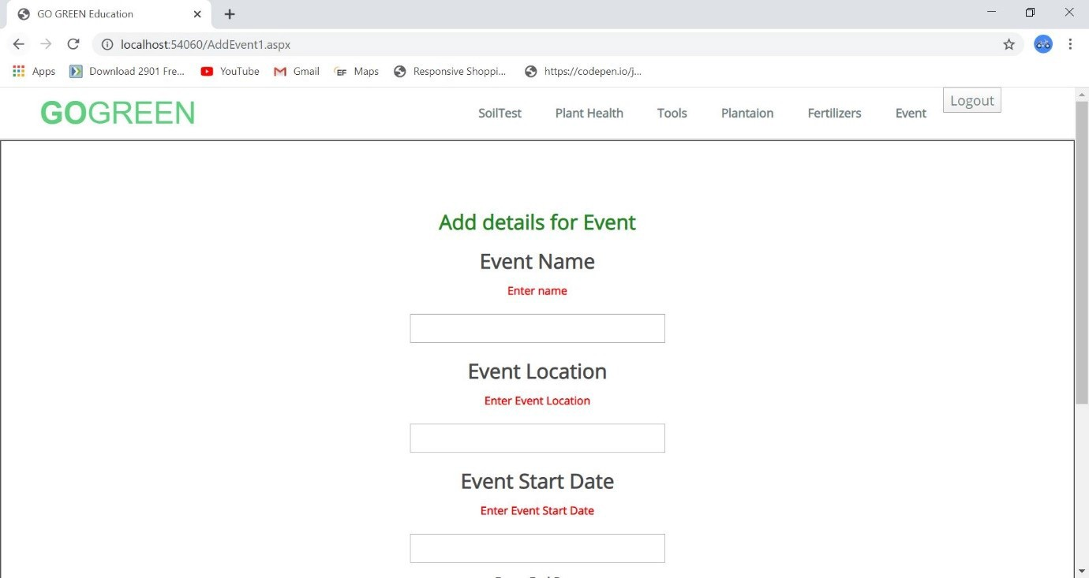

**[Figure: Event Validation]**

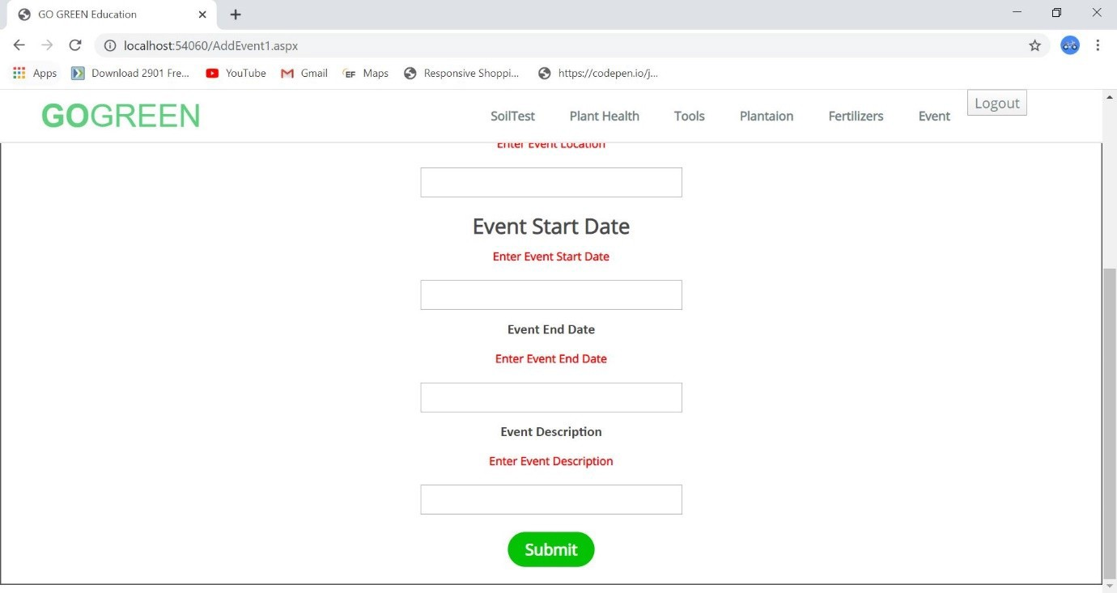

**[Figure: Event Validation Scroll]**

50

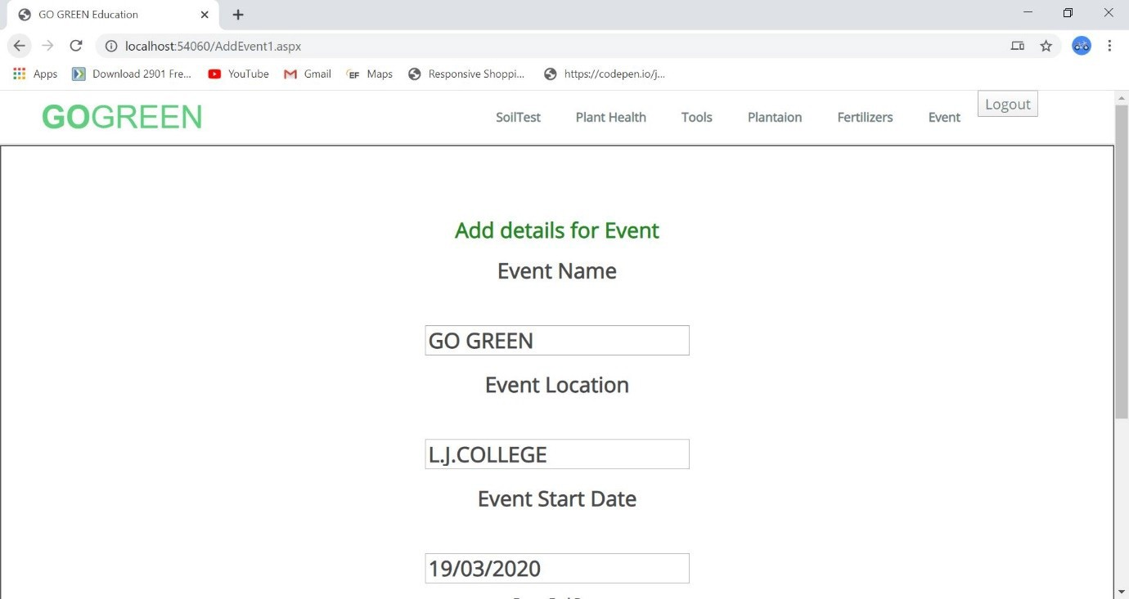

**[Figure: Event Add Form]**

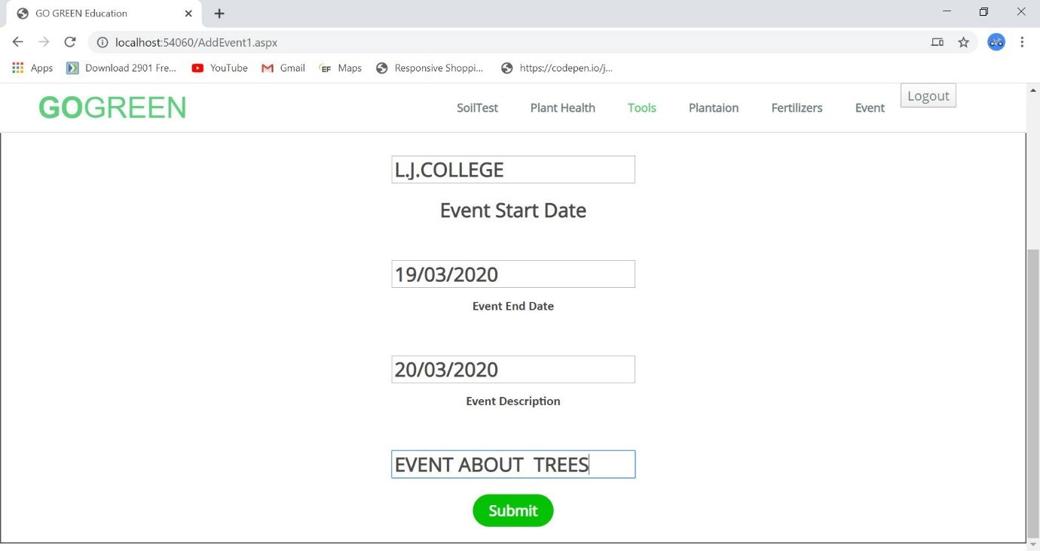

**[Figure: Event Submit Scroll]**

51